**Design Thinking Project Workbook**

**Don't find customers for your product but find products for your customers**

**1. Team**

**Team Name:**

**Mounisha**

**Team Members:**

K Mounisha 2320030010@klh.edu.in

**2. Problem/Opportunity Domain**

**Domain of Interest:** Video Summarization & Content Creation Tools

**Description of the Domain:** The rise of video content consumption has created a demand for efficient ways to condense and summarize long videos, saving users time while still delivering the key insights.

**Why did you choose this domain? :** I chose this domain due to the rapid growth of online educational videos, where long lectures could benefit from concise summaries, providing users with quicker access to essential information.

**3. Problem/Opportunity Statement**

**Problem Statement:** Users of YouTube often face the challenge of spending too much time watching videos in full to get the main points. There is a need for a tool to generate concise summaries of video content automatically.

**Problem Description:** Video consumers often want to quickly extract the key points from long-form content. Manually skimming or watching entire videos can be time-consuming, especially when users are only looking for specific information.

**Context (When does the problem occur):** The problem occurs when users seek a quick understanding of educational or informative videos.

**Alternatives (What does the customer do to fix the problem):** Customers currently rely on manual skimming or searching through comments or descriptions for summaries**.**

**Customers (Who has the problem most often):** Students, researchers, and professionals who consume educational or informative video content.

**Emotional Impact (How does the customer feel):** Customers feel frustrated when they cannot efficiently extract the key points, wasting time watching irrelevant content.

**Quantifiable Impact (What is the measurable impact):** Increased time spent per video, decreased productivity when researching or studying, and reduced content consumption efficiency.

**Alternative Shortcomings (What are the disadvantages of the alternatives):** Current alternatives, like comments or third-party summaries, may not always capture all the important details, and often users still need to manually skim through the video.

**Any Video or Images to showcase the problem:**

Video link:[**https://youtu.be/_uQrJ0TkZlc?si=eOe4qV8hJgEtbCZ-**](https://youtu.be/_uQrJ0TkZlc?si=eOe4qV8hJgEtbCZ-)

This video is over 6 hours long, making it time-consuming for users who are only seeking a summary of the main ideas presented in the video.

**4. Addressing SDGs**

**Relevant Sustainable Development Goals (SDGs):** SDG 4: Quality Education, SDG 9: Industry, Innovation, and Infrastructure.

**How does your problem/opportunity address these SDGs? :** By providing quick access to key educational content through video summarization, we support SDG 4. Additionally, our tool enhances the digital infrastructure for content consumption, addressing SDG 9.

**5. Stakeholders**

Answer these below questions to understand the stakeholder related to your project

1. **Who are the key stakeholders involved in or affected by this project?**

• End-users (students, professionals)

• YouTube content creators

• Educational institutions

• AI/ML model providers (Google Gemini)

1. **What roles do the stakeholders play in the success of the innovation?**

• End-users utilize the tool for their learning and research.

• Content creators benefit from having their content summarized for broader accessibility.

• Institutions could implement the tool in e-learning platforms.

• Google Gemini provides the AI capabilities for generating content.

1. **What are the main interests and concerns of each stakeholder?**

• End-users want fast, accurate summaries.

• Content creators may be concerned about losing viewership.

• Institutions are interested in improving learning outcomes.

• AI providers focus on the tool's performance.

1. **How much influence does each stakeholder have on the outcome of the project?**

High influence from end-users and content creators, as their feedback directly affects the success of the tool.

1. **What is the level of engagement or support expected from each stakeholder?**

**• End-users (students, professionals):** High engagement, as their feedback drives improvements.

**• YouTube content creators:** Moderate, as they may monitor how their content is summarized.

**• Educational institutions:** Moderate, with potential for tool integration.

**• AI/ML providers (Google Gemini):** High, for technical support and ensuring model performance.

1. **Are there any conflicts of interest between stakeholders? If so, how can they be addressed?**

**Creators:** Concern about reduced viewership from summaries.

Solution: Emphasize increased engagement and accessibility.

**End-users vs. monetization:** Users may expect free access, while creators prefer monetization.

Solution: Offer free basic features with premium options.

1. **How will you communicate and collaborate with stakeholders throughout the project?**

**End-users:** Surveys, forums, social media.

**Creators:** Creator platforms, feedback.

**Institutions:** Emails, demos, meetings.

**AI providers:** Ongoing technical support and documentation.

1. **What potential risks do stakeholders bring to the project, and how can these be mitigated?**

End-users: Inaccurate summaries.

*Mitigation:* Continuous model improvement via feedback.

Creators: Full content may seem undermined.

*Mitigation:* Highlight benefits of increased engagement.

Institutions: Slow adoption.

*Mitigation:* Provide clear integration support.

AI providers: Service disruptions.

*Mitigation:* Diversify AI models.

**6. Power Interest Matrix of Stakeholders**

**Power Interest Matrix: Provide a diagrammatic representation of Power Interest Matrix**

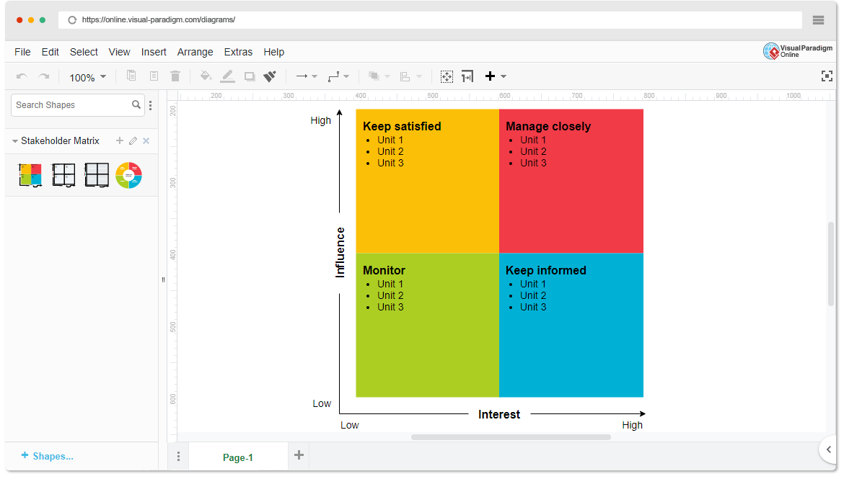

**High Power, High Interest:** End-users (students, professionals)

**High Power, Low Interest:** Content creators

**Low Power, High Interest:** Educational institutions

**Low Power, Low Interest:** General video viewers not interested in summaries.